Data Preparation

Q1.
For 5th row the weight computed is 85.25 kg,
for 8th row the height computed is 180.0 cm.

Q2.
The new values assigned after replacing strategy parameter from ‘mean’ to ‘median’
are:
weight is 5th row : 88.5 kg
height in 8th row : 179.0 cm

Q3.
It splits the column which contains numerical categorical data to many columns depending on the number of categories present in that column. Each column contains “0” or “1” corresponding to which column it has been placed.

Q4.
Because OneHotEncoder splits the categogical data in 1st column to three columns of “0” and “1”.

Q5.
The output gives the standardized data of every column calculated separately.
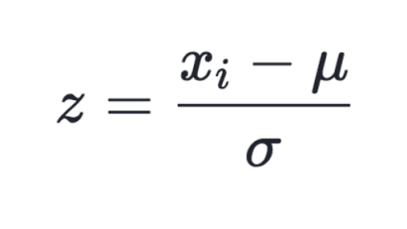
When we change the test size from 20% to 30%, the mean and standard deviation of the training data changes thus changing the standardized output.

Dim Reduction

Q1.
The hyperplane shadow represents the plane containing the two orthonormal eigenvectors pertaining to values that have maximum variance. Thus it can be used as the 2D representation of the 3D output.
It preserves all high variance point.

Q2.
After PCA transformation the reconstruction loss is about 0.01017033779

Q3.
Green part is segregated in 2 ways so straight line classifier cannot classify this.

Q4.
Squashing the swiss roll means projecting the values into a 2D plane which results in overlapping of values.
Unrolling the swiss roll means unfolding the swiss roll to a 2d plane in such a way that no values superimpose or overlap on one another.

Q5.
PCA algorithm works as follows:
- First the inputs are standardized so that they are brought to similar scale. Mathematically this is done by-
X = (X – mean)/standard deviation
- Next covariance matrix of data set is computed to check how input data varies from mean and correlation is identified.
- Eigen Vectors and Eigen Values are computed to identify principal components that are uncorrelated components.
- This process helps in reduction of dimensions without losing much information.

Q6.
The output plot changes and reconstruction error reduces to great extent.

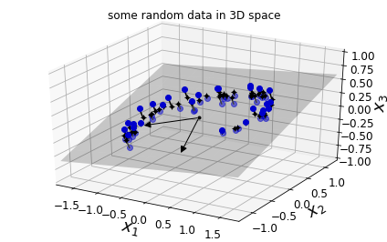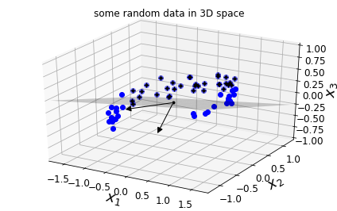

n_components=2 n_components=3
Reconstruction error= 0.0101703377928485 Reconstruction error=4.50104673713285e-31

